## 2.4 Activity Diagrams

**1. Diagrams for a select number of pages use-case**

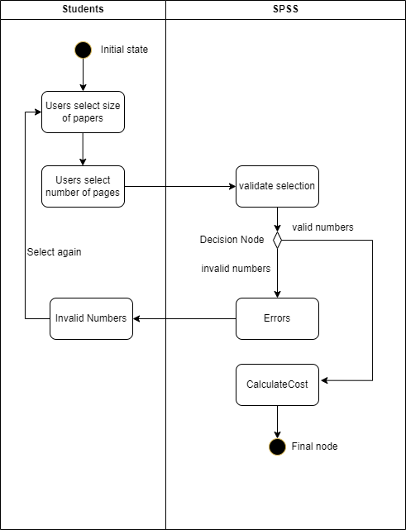

This diagram illustrates the process for students to select the number of pages they wish to purchase. Initially, they choose the desired paper size (such as A3, A4, etc.), followed by the number of pages. SPSS then verifies the validity of the selected numbers. If the numbers are valid, the process proceeds to the next step; otherwise, it redirects back to the initial for students to reselect the appropriate number of pages.

**3. Use-case: Payment Processing**

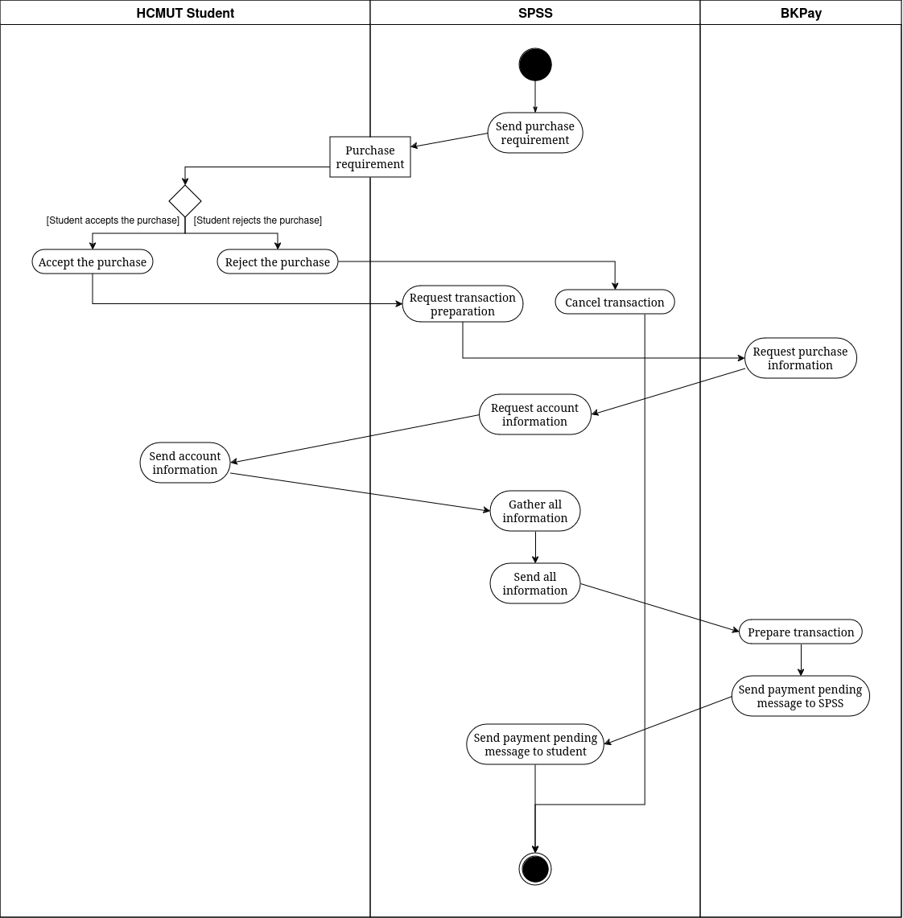

The above activity diagram illustrates activities involved in the Payment Processing use case. Firstly, the SPSS sends a purchase request to the student. Should the student reject the purchase, the SPSS will cancel the transaction. On the other hand, the SPSS will request the BKPay system to prepare the transaction. To do that, the BKPay will request purchase information from the SPSS, which will request account information from the student. Then, the student provides the required information, and the SPSS gathers all the data and sends it to BKPay. The BKPay starts preparing the transaction and sends a payment pending message to SPSS, which will transfer it to the student.

**4. Use-case: Confirm Purchase**

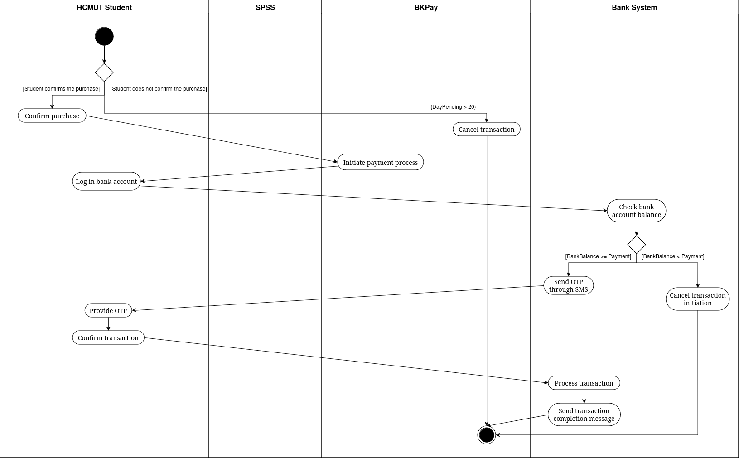

The above activity diagram describes activities involved in the Confirm Purchase use case. Firstly, the student decides whether to confirm the purchase. The purchase will only be canceled if the student affirms the transaction within 20 days after its creation on the BKPay system. As soon as the student confirms, the BKPay will initiate the payment process. The student then logs in to his or her bank account. After that, the bank system checks the student's bank account balance. Should the balance be lower than the payment, the initiation will be terminated. On the other hand, as soon as BKPay finishes sending the OTP through SMS, the student must provide the OTP in an interval of time and confirm the transaction to complete the process. The BKPay will handle the purchase, and when the buy is successful, it will send a transaction completion message to the SPSS, BKPay, and the student.

## 2.5 Sequence Diagrams

**1. Use-case: Select number of papers**

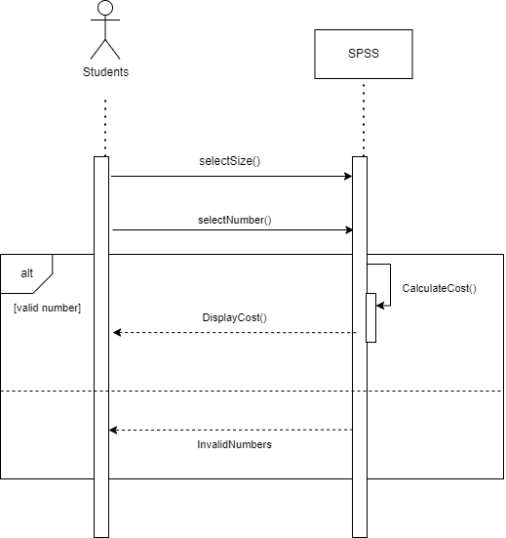

This diagram illustrates the process students follow to select the number of pages they want to purchase. Initially, they choose the desired paper size (e.g., A3, A4, etc.), and then specify the number of pages. The SPSS system checks the validity of the selected pages. If the numbers are valid, it calculates the cost and displays it to the students. If the numbers are invalid, the system throws an error indicating the invalid selection.

**2. Use-case: Payment Processing**

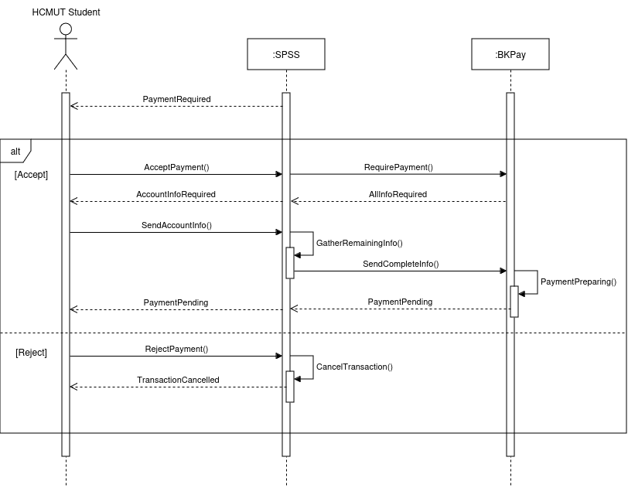

The above sequence diagram represents a sequence of interactions between a HCMUT student, SPSS, and BKPay in the Payment Processing use case. As soon as the student finishes setting the purchase, the SPSS will require payment. If the student does not accept the payment, the system will terminate the transaction and then send back an announcement of the transaction canceling. On the other hand, the SPSS will require the BKPay to make a new payment. Next, the BKPay system sends a message to SPSS demanding transaction information. The SPSS asks the student to provide account information, combined with buying information and sends it to BKPay. Finally, the BKPay system will prepare a payment, waiting for the student to confirm the purchase.

**3. Use-case: Confirm Purchase**

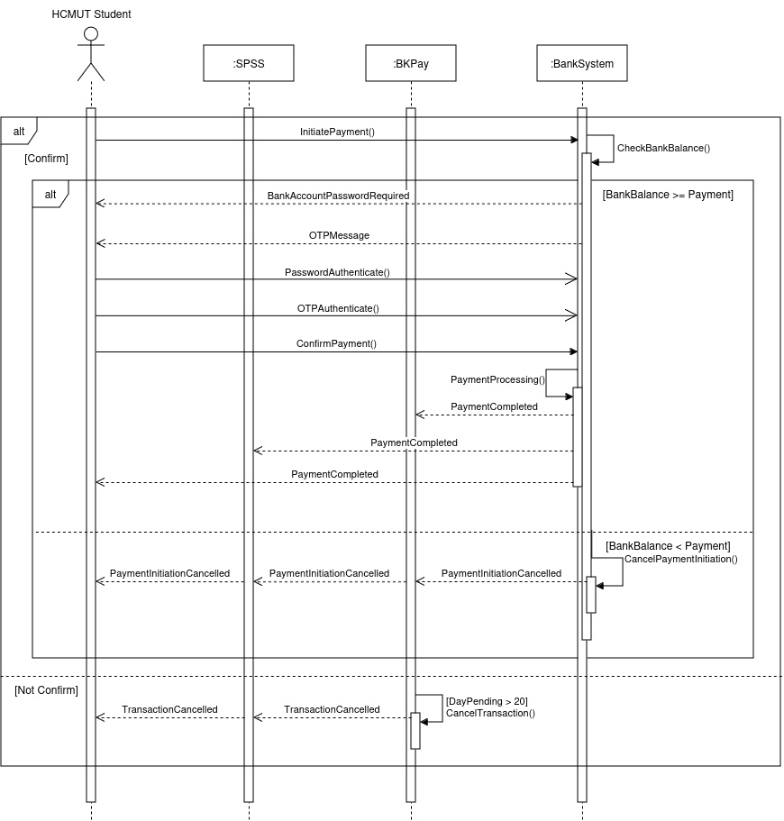

The above sequence diagram represents a sequence of an HCMUT student, SPSS, BKPay, and bank system in the Confirm Purchase use case. Now, there is a payment in the BKPay system waiting for the student to confirm. The transaction will be canceled if the student does not execute it for the next 20 days since the payment request is created and prepared. On the other hand, BKPay will initiate the payment process. Next, the student's browser is redirected to the bank website. If the bank balance is lower than the payment, the purchase initiation will be canceled. If not, the bank system will ask for the bank account password and OTP code sent through an SMS message. The purchase is then processed, and a completion message will be sent to BKPay, SPSS, and the student.

## 2.6 Class Diagrams

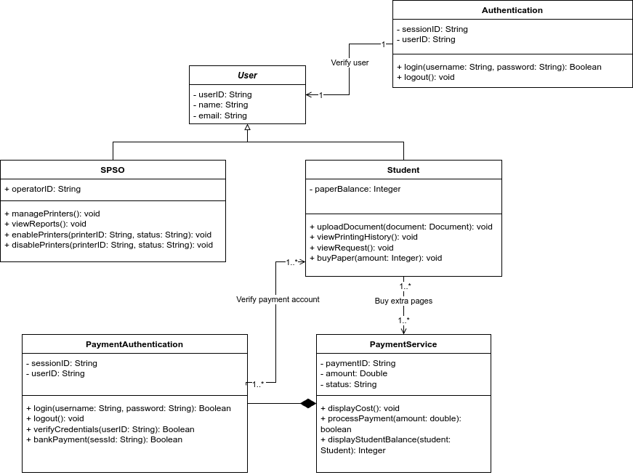

This class diagram represents a system designed to manage student printing services and paper purchases. The main entities are **User**, **Student**, **SPSO**, **Authentication**, **PaymentAuthentication**, and **PaymentService**. **User** is the base class with attributes such as **userID**, **name**, and **email**, and it links to **Authentication** through a **one-to-one (1..1)** relationship to verify login sessions using **login** and **logout** methods. **Student** inherits from **User** and has a unique attribute, **paperBalance**, along with methods to upload documents, view history, make print requests, and buy additional paper. **SPSO** (Student Printing Service Operator) also extends **User**, adding capabilities for managing printers and viewing reports, with specific methods to enable and disable printers. **PaymentAuthentication** provides methods for verifying credentials and handling bank payments, serving as a gateway for the **PaymentService** class. The **PaymentService** class includes attributes for transaction details and methods to display costs, process payments, and check a student’s balance. In this system, **Student** has a **one-to-many (1..*)** relationship with **PaymentService**, meaning each Student can perform multiple transactions, while each payment transaction is associated with only one **Student**. Additionally, **Student** has a **one-to-one (1..1)** relationship with **PaymentAuthentication**, as each payment session requires a unique authentication. Aggregation relationships show that **Student** may need to purchase paper through **PaymentService**, and a composition link between **PaymentAuthentication** and **PaymentService** indicates that payment verification is essential for the transaction process. These cardinalities define the interactions within the system, specifying how students manage their printing services, make payments, and authenticate transactions under the system’s defined roles.

## 2.7 MVP 1: User Interfaces

After logging in, students can access the “Buying Paper” page by selecting it from the main navigation bar. The following steps guide the process of purchasing paper:

1. **Select the Number of Pages:**

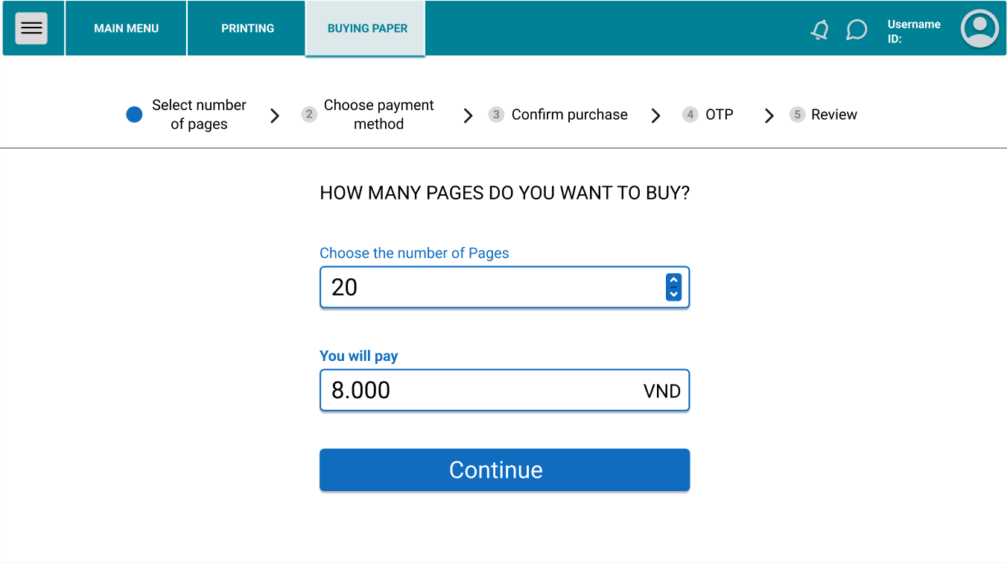

The student chooses the desired number of pages to buy. Based on the selection, the cost is calculated and displayed. Click “Continue” to proceed.

1. **Choose Payment Method**:

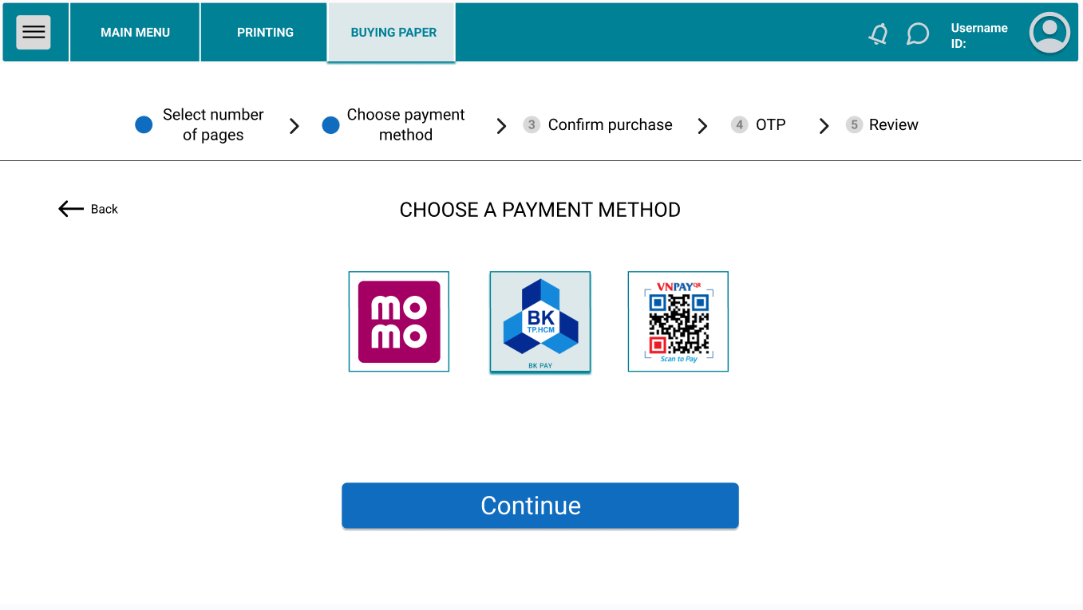

The student selects a preferred payment method by clicking on one of the available options, such as MoMo, BKPay, or VNPay QR. Click “Continue” to move forward.

1. **Confirm Purchase Details:**

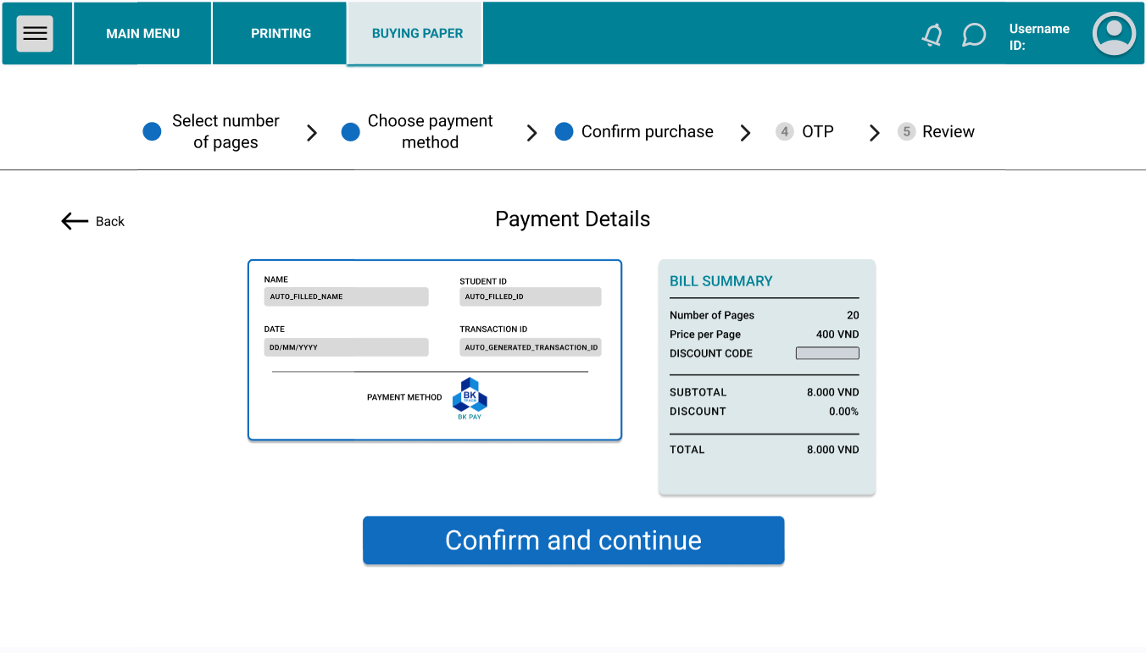

The student reviews the payment details, including the selected page quantity, cost per page, and total amount. If everything is correct, click “Confirm and continue”.

1. **OTP Verification:**

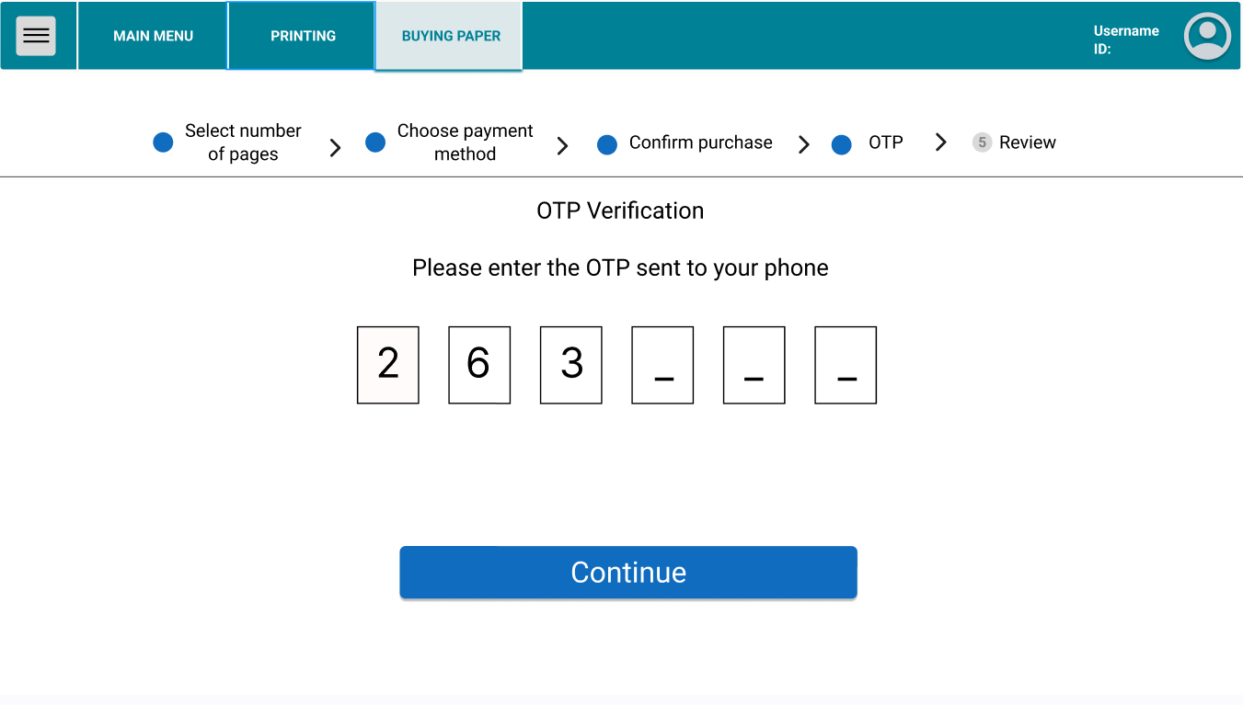

The student enters the OTP code sent to their phone to verify the transaction. Input the OTP and click “Continue”.

1. **Transaction Success:**

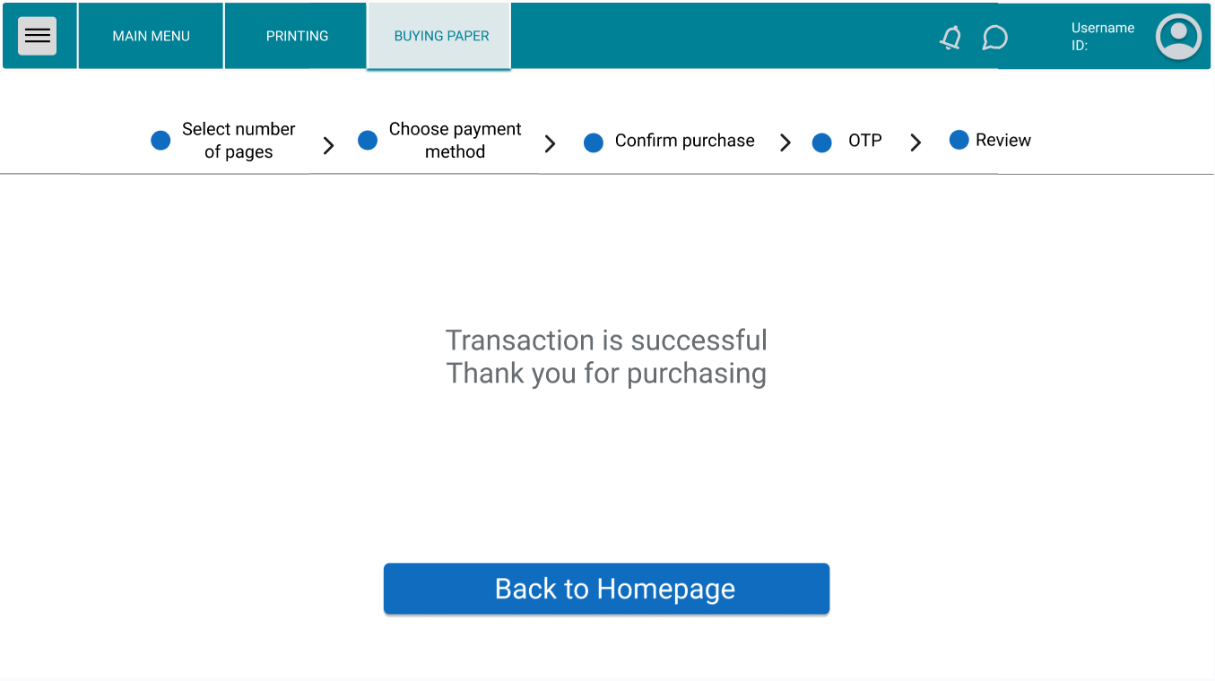

After successful payment, a confirmation message appears. Click "Back to Homepage" to return to the main page.

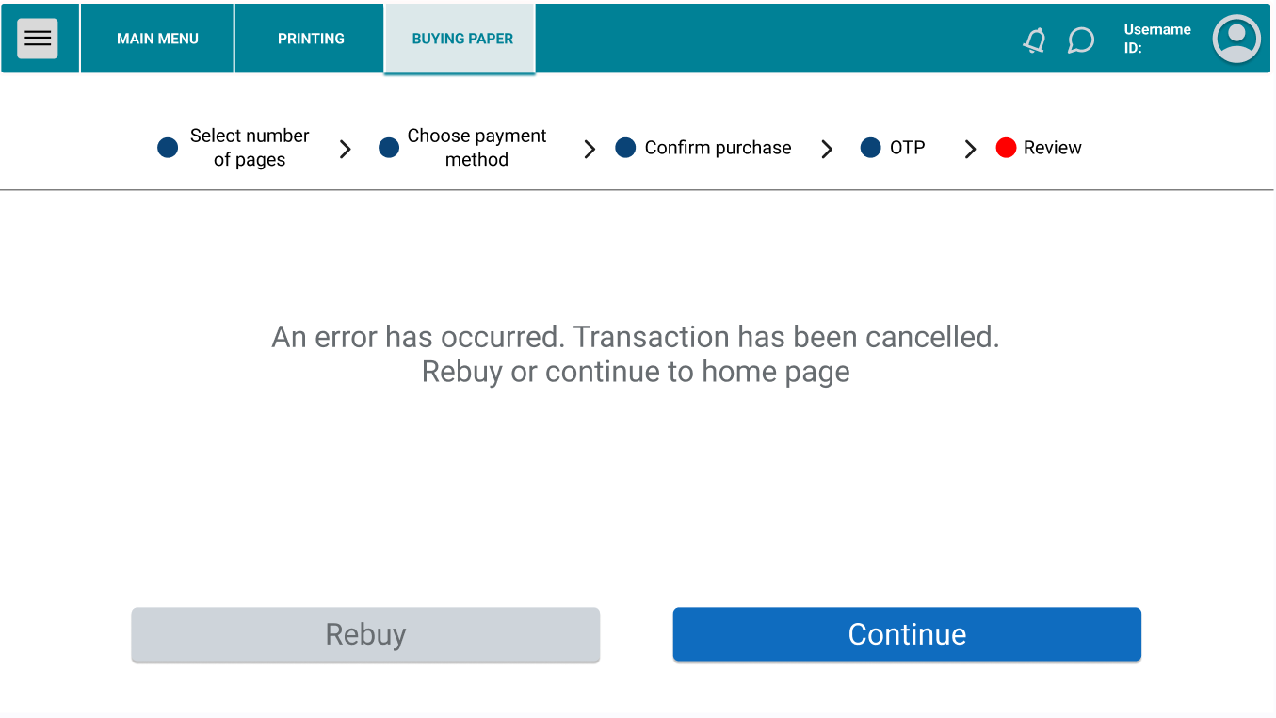

If an error occurs, a message will display, notifying the student that the transaction has been canceled. They can either attempt to “Rebuy” or click “Continue” to return to the homepage.